- KUJIRIDHISHA USAHIHI WA VENUE (TEAM)
Lengo: Kuhakikisha maeneo yote ya kufundishia yana taarifa sahihi na yanapatikana.
Shughuli Kuu:
- Kukagua majina ya venue, uwezo (capacity), aina (darasa, maabara n.k.), Department.

- 3. KUJAZA TAARIFA ZA TUTOR, PROGRAMS, MODULES NA VENUES (EACH TEAM ON ITS DEPARTMENT) - EXCEL NA FORM
Lengo: Kuhakikisha msingi sahihi wa uandaaji wa ratiba.
Shughuli Kuu:
Kujaza taarifa za:
- TUTORS - EXCEL
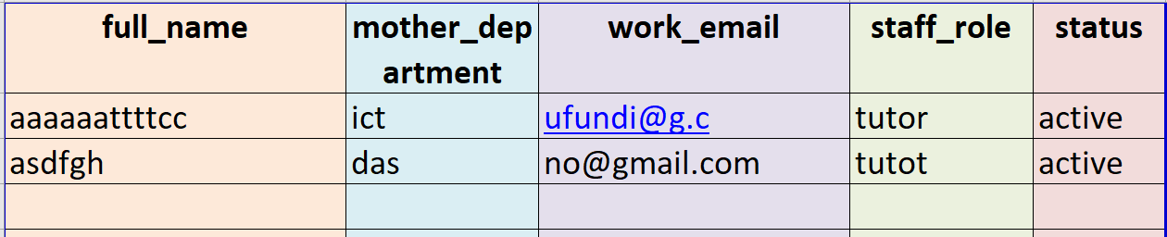
RULES
- FULL NAME SHOULD BE SAME AS OFFICIAL KNOWN NAME.
- MOTHER DEPARTMENT SHOULD BE SAME LIKE REGISTERED DEPARTMENT
- WORK EMAIL SHOLD BE THE OFFICIAL EMAIL USED AT INSTITUTION
- STAFF ROLE SHOULD BE tutor or hod or t-master
- STATUS SHOULD BE active or inactive

- PROGRAMS -EXCEL
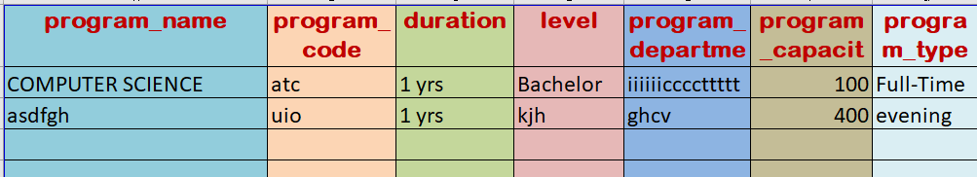
RULES
- PROGRAM NAME SHOULD CAPITALIZE EACH WORD FORMAT
- PROGRAM CODE SHOULD STATART WITH LEVEL (I.E. L7-1, L8, L6) FOLLOWD FIRST CHARACTER OF EACH WORD IN PROGRAM NAME
Example For program level 8 Computer Science should be L8CS, FOR Level 7-2 Computer Science will be L7-2CS
- PROGRAM DURATION SHOULD BE IN THIS FORMAT 1 Yrs, 2 Yrs, ….
- LEVEL SHOULD BE DIPLOMA, VETA AND DEGREE
- PROGRAM DEPARTMENT MUST BE SAME AS REGISTERED DEPARTMENT
- PROGRAM CAPACITY SHOLD BE THE WHOLE NUMBER
- PROGRAM TYPE MUST BE EXACT LIKE full-time, evening and VETA.
- EVENING PROGRAM CODE MUST END WITH “-E”

- VENUES - EXCEL
RULES
- VENUE NAME SHOULD BE A SENTENCE CAPITALIZED EACH WORD FOR CONSISTENCE
- VENUE CAPACITY MUST BE A WHOLE NUMBER GREATER THAN 0
- VENUE LOCATION SHOULD BE KNOWN TO MEMBERS OF COLLEGE WE RECOMMEND FAMOUS NAMES
- VENUE TYPE MUST BE Lab or Theory
- VENUE DEPARTMENT MUST BE EXACT THE SAME AS REGISTERED DEPARTMENT

- MODULES (REGISTERED_SUBJECTS EXCEL)
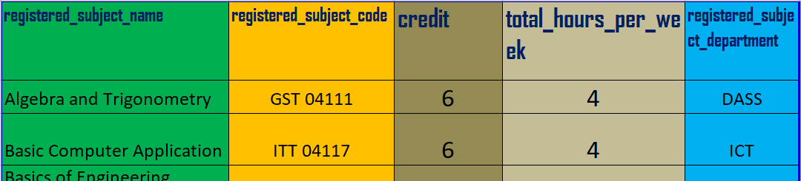
RULES
- REGISTERED SUBJECT NAME SHOULD BE CONSISTENT
- REGISTERED SUBJECT CODE SHOULD START WITH CAPITAL LETTER CHARACTER FOLLOWED BY NUMBER FOR CONSISTENCE
- REGISTERED SUBJECT CODE SHOULD HAVE SPACE BETWEEN CHARACTERS AND NUMBERS (I.E GST 041111)
- REGISTERED SUBJECT CREDIT SHOULD BE A WHOLE NUMBER FROM ZERO
- TOTAL HOURS PER WEEK SHOULD REFLECT LTPA
- REGISTERED SUBJECT DEPARTMENT MUST BE EXACT THE SAME AS REGISTERED DEPARTMENT

Ku-upload taarifa zote kwenye mfumo wa ratiba.
picha za excel zilizotolewa ni mifano tu, sio data halisi
Kigezo cha Ubora: Hakuna taarifa itakayopitishwa bila uhakiki wa pili.

- KUFANYA ASSIGNING YA MASOMO KWA TUTORS (EACH TEAM ON ITS DEPARTMENT)
Lengo: Kugawa masomo kwa tutors kwa usawa na ufanisi.
Shughuli Kuu:
- Kufanya assigning kupitia Excel au Web Form.
- Kuzingatia mzigo wa kazi wa tutor, utaalamu na upatikanaji wake.
- Kwa program code zinazoungana tumia (+ sign) kwenye Excel
- Andika Email Sahihi ya tutor inayoendana na Email iliyosajiriwa kwenye mfumo
Muonekano wa excel itakayotolewa lazima uwe na header kama ifuatavyo (user_email, subject_code, program_code, total_hours_per_week, type_prac_or_theory) Excel ya assign tofauti na muundo huu hairuhusiwi.
Huu ni mfano wa excel iliyo jazwa
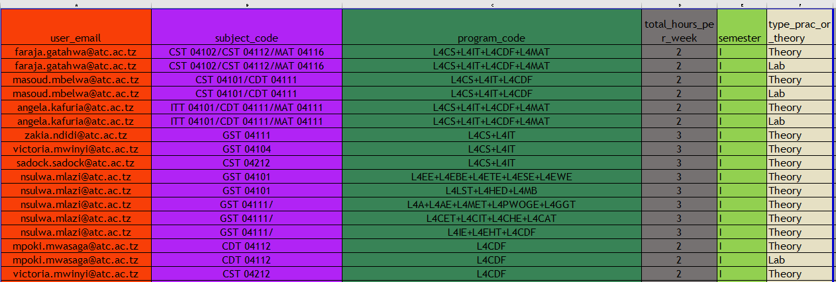
Baada ya kujaza upload ile sehemu ya allocate module (HOD / t-master Ndiye anaweza upload)
RULES
- USER EMAIL MUST BE EXACT SAME AS REGISTERED TUTOR EMAIL (FOREIGN KEY)
- SUBJECT CODE FOR COMBINED PROGRAM WITH DIFFERENT SUBJECT CODE SHOULD BE SEPARATED BY “/”
- IN SUBJECT CODE LEAVE SPACE TO SEPARATE CHARACTER AND NUMBER IN SUBJECT CODE
- PROGRAM THAT SHARES SAME SUBJECT MUST BE CONCATENATED BY “+” SIGN
- TOTAL HOURS PER WEEK (LTPA) SHOLD BE WHOLE NUMBER FROM 0 AND ABOVE PREFERRED INTERVAL IS INTERVAL OF 1.5 (I.E., 1.5,3,4.5,6 ….)
- SEMESTER SHOULD BE IN ROMAN NUMBER (UPPERCASE) E.g. I, II, III, IV
- TYPE PRAC OR THEORY MUST BE Theory, Lab, Theory-Lab, Lab-Theory
- ANY CONCANTENATION THAT CONTAIN EVENING PROGRAM ALL THAT END WITH -E AND FULL TIME PROGRAM WILL BE ALLOCATED IN MID TIME BETWEEN EVENING AND FULL TIME EXAMPLE (L8BIT + L8BIT-E) WILL BE ASSIGNED AT MID TIME RANGE LIKE 17:10 TO 18:00
- EVENING PROGRAM CODE MUST END WITH “-E”
SUBJECT
- KU-GENERATE RATIBA (EACH TEAM ON ITS DEPARTMENT)
Lengo: Kutengeneza ratiba inayotekelezeka na inayozingatia mahitaji halisi.
Njia:
- Semester I: Ku-generate ratiba kwa njia ya Manual ili iendane na hali iliyopo.
- Semester II: Ku-generate ratiba kwa kutumia Auto Generate Form ya mfumo.
Tahadhari: Kuhakikisha vigezo vyote (venues, tutors, programs) vimezingatiwa kabla ya ku-generate.
- KUKAGUA RATIBA BAADA YA KU-GENERATE (EACH TEAM ON ITS DEPARTMENT)
Lengo: Kudhibiti ubora wa ratiba.
Shughuli Kuu:
- Kukagua migongano ya muda, venue au tutor.
- Kuhakikisha mzigo wa masomo uko katika viwango vinavyokubalika.
- Kuthibitisha ufanisi wa ratiba kwa upande wa wanafunzi na wakufunzi.

- KUTOA RIPOTI YA CHANGAMOTO (EACH TEAM ON ITS DEPARTMENT)
Lengo: Kuboresha mfumo na mchakato kwa ujumla.
Shughuli Kuu:
- Kuandaa ripoti ya changamoto zilizojitokeza.
- Kupendekeza suluhisho za kitaalamu.
- Kuwasilisha ripoti kwa T-Master/Paneli Kuu kwa maamuzi.

- MENGINEYO NA HITIMISHO (TEAM)
Lengo: Kuhitimisha mchakato kwa umoja na weledi.

TABLE ZA KUANZA NAZO
  - DEPARTMENT
  - PROGRAMS
  - REGISTERE SUBJECTS
  - VENUES
  - TUTORS
  - ALLOCATE MODULE TABLE
  - MANUAL OR AUTO GENERATE

